PS Audio Music Server Development

Hardware based computer products for accessing, recording, storing, cataloging and playing digital audio. Controlled by both an internal webpage as well as an external IOS app, the product should be plug and play ready to install in the user’s home and be operable by customers with zero computer or networking skills.

Usage model, for ease of installation and operation, is Sonos.

Model opportunities range from simple, extremely low cost modules that can be built into products (self powered speakers, DACs, integrated amplifiers), to low cost standalone servers and players, and higher priced full chassis integrated units.

Architecture
The music server is based on local hardware, the most basic something similar to a Raspberry Pi, addressable over a LAN, controlled by either a built in web page or IOS app, with access to our proprietary cloud server for metadata.

Common to all models
- Auto boot and reboot, using watch timer, in case of failure
- Auto search and index any attached share
- Intuitive default setup requiring zero user interaction
    - Lower layers of user defined options
- Auto search and detect LAN for available music shares
- Detach music shares without notification and damage
- Compatible with iTunes library
- Internal MySQL database (or equivalent) stores all data for attached music shares and selected streaming artists
- Use existing metadata and cover art if available
- Internal hard drive models offer some means of external backup (through USB drives or cloud)
- Auto detect USB CD/DVD ROM drive attached
  - According to user defined setup, auto rip, catalog and add to library
- Upgradable via auto download and install
- Reset/panic button on back panel
- No fans
- RS232, IP, or similar input required for inputting unit ID/MAC address
- All the heavy lifting (computing) to be performed on the local hardware.
- Indexing attached music shares
- Requesting and storing metadata and photos
- Building an internal database of the attached music shares
- Interfacing with iPad app
- Local web server
- Supported File Types
  - AAC
  - AIFF
  - ALAC
  - APE
  - DFF
  - DSF
  - FLAC
  - MP3
  - OGG
  - WAV
  - WV
  - WMA
- PCM in 44.1Khz - 384Khz at 16 - 32bits
- DSD 2.8224MHz and 5.6448MHz

Defining Concept
The music server takes the user’s existing music collection, whether in CD form (for ‘Best’ version only), as pre-existing music files located on the user’s computer (all versions), or as music delivered from a supported streaming service (all versions). It improves upon the user’s existing computer-based music server opportunities by:
- Providing a command-and control interface that runs on a separate mobile device such as Apple iPad (to be supplied by the User).
- Simplifying the process of connecting and configuring the audio hardware.
- Providing an intuitive and flexible User experience in browsing and managing a large music collection.
Providing a hardware platform optimized around the specific needs of high-end digital audio playback performance.

- User Stories
  - Defines how the target user will interact with the device and software once it is complete. The idea is to describe the common scenarios the user will encounter and how the hardware and software work together to deal with these scenarios.

    - Initial Setup
      - As a user, I’ve just purchased a new music server and want to import my existing collection of digital music.
      - As a user, I’ve just purchased a new music server and want to import my existing collection of CDs.
      - As a user, I want to browse my new music server.
      - As a user, I want to set up my new music server to use my existing DAC.
    - Continuing Setup
      - As a user, I’ve just purchased a new digital download and want to import it.
      - As a user, I’ve just upgraded my DAC and want to configure my music server to use it.
    - Management
      - As a PS Audio manager, I want to understand how my customers are using the music server.
      - As a PS Audio manager, I want to know if there are stability problems with the music server than should be resolved in an update.
      - As a PS Audio manager, I want to know how many music servers have been updated to the latest software.

- Hardware

  - Additional variations are possible beyond those listed in this section. Defined here are good, better, and best versions. It is assumed that the best version is the baseline for the development process.

  - Best Version . Includes a CD Ripper, an on board HDD, and a LCD touchscreen color display, in the PS Audio top of the line style chassis

    - Connectors
      - Power – IEC inlet
      - USB – 4 USB 2.0 A ports on back panel. 1 on front panel
      - I2S – HDMI connector
      - S/PDIF – RCA connector
      - AES/EBU – XLR connector
      - Ethernet – RJ45 connector
      - RS232 – DB9
    - Chassis – PerfectWave style 5” tall
    - Power – 120V 60Hz or 230V 50Hz.
    - CPU – Raspberry Pi 2 or equivalent

  - Better Version. Similar to the best version but without the CD ripper. It uses a less expensive OLED display and a front panel knob or button(s) for user input. The chassis is a thinner version of the PerfectWave style.
    - Connectors
      - Power – IEC inlet
      - USB – 4 USB 2.0 A ports on back panel. 1USB on front panel
      - I2S – HDMI connector
      - S/PDIF – RCA connector
      - AES/EBU – XLR connector
      - Ethernet – RJ45 connector
      - RS232 – DB9
    - Chassis – PerfectWave (DS Jr) Style. 3” tall
    - Power – 120V 60Hz or 230V 50Hz.
    - CPU – Raspberry Pi 2 or equivalent

  - Good Version . There is no CD ripper or internal HDD in this unit. Also no display. The only user feedback will be from LEDs in the front panel. If user input is required it will be with buttons on the front. The chassis will utilize the PS Audio lower cost “Stellar” design.
    - Connectors
      - Power – IEC inlet
      - USB – 4 USB 2.0 A ports on back panel. 1USB on front panel
      - I2S – HDMI connector
      - S/PDIF – RCA connector
      - AES/EBU – XLR connector
      - Ethernet – RJ45 connector
      - RS232 – DB9
    - Chassis – PerfectWave (DS Jr) Style. 3” tall
    - Power – 120V 60Hz or 230V 50Hz.
    - CPU – Raspberry Pi 2 or equivalent

3 In-the-Box Software Environment (system services)
Definition of all software and configurations thereof that constitute the system image. This might need to change for different specifications of hardware. This does not include custom software development.
  - Linux
    - Latest stable version of Debian that is compatible with chosen SBC
    - Kernel build configuration details to be determined after selection of SBC
    - ALSA configuration will be the latest stable version
    - Hardware to include ability to make a console connection to Linux
    - Network file services capable of reading every different configuration that is likely to be encountered.
      - SMB:, AFS:, NFS:, … what else?
      - FAT, NTFS, Mac, … what else?
      - Any compatibility concerns with various NAS systems?
    - Capability to Watch/Auto-Detect/Auto-Import from network locations?
      - Managing network locations that go temporarily off-line.
    - Linux driver for touchscreen display
    - Linux driver for OLED display
    - File system is zfs
    - Redundancy
      - System
        - Periodic health checks
        - Redundant code image
        - Watch dog/ auto reboot
      - User Data - TBD
      - User Music - TBD
  - MPD
    - Customized to use external database
    - Custom interface to database
  - CD Ripper
    - Auto-mount
      - Default file location internal HDD if available. If it isn’t what do we do?
      - Naming conventions etc. TBD
    - Auto-rip (?)
      - What default format?
      - Does this mean you can’t play a disc (transport functions)?
      - What if it is a data disc?
      - What if it is an SACD
  - Database
    - Software / version
    - Required at all (vs. using embedded DB)
  - Web Server
    - Latest Stable version of Apache
- In-the-box System Software (custom development)

  - Definition of all newly built software, including database schemas, that will be installed on the box. This could potentially vary due to changes in the hardware configuration and the software environment.

  - Requirements
    - Interface to Paul Taylor’s metadata
      - API definition
    - Interface to MPD
      - Playback control
      - Volume control (?)
      - Playback status (current track, position, etc…)
    - API definition
      - Strongly depends upon interface to Paul Taylor’s metadata
  - Architecture
    - Database schema
      - Choice of architecture (SQL vs. no-SQL)
      - Definition of tables
      - Definition of queries
    - Single vs . multiple processes
      - Embed the server and MPD control in one process (?)
      - Heartbeat system to recover from crashes (?)
    - Development platform
      - Language (C++)
      - Toolkit (Qt)
      - etc…
  - Features
    - Auto-scan and import of music
    - Local/cloud backups (?)
    - etc…
- Interfacing Software (iOS and Android)

Definition of the applications the user will interact with. Limited to mobile platforms (iOS and Android.) This should specify types of device (tablets vs. phones), models of device (iPad Pro vs. iPad Air) and versions of the underlying operating systems supported (iOS 9 vs. iOS 6 through 9.) It should also include the features we want in the applications, wireframes for the design and flow and eventually, a fully designed spec with assets/images, etc…

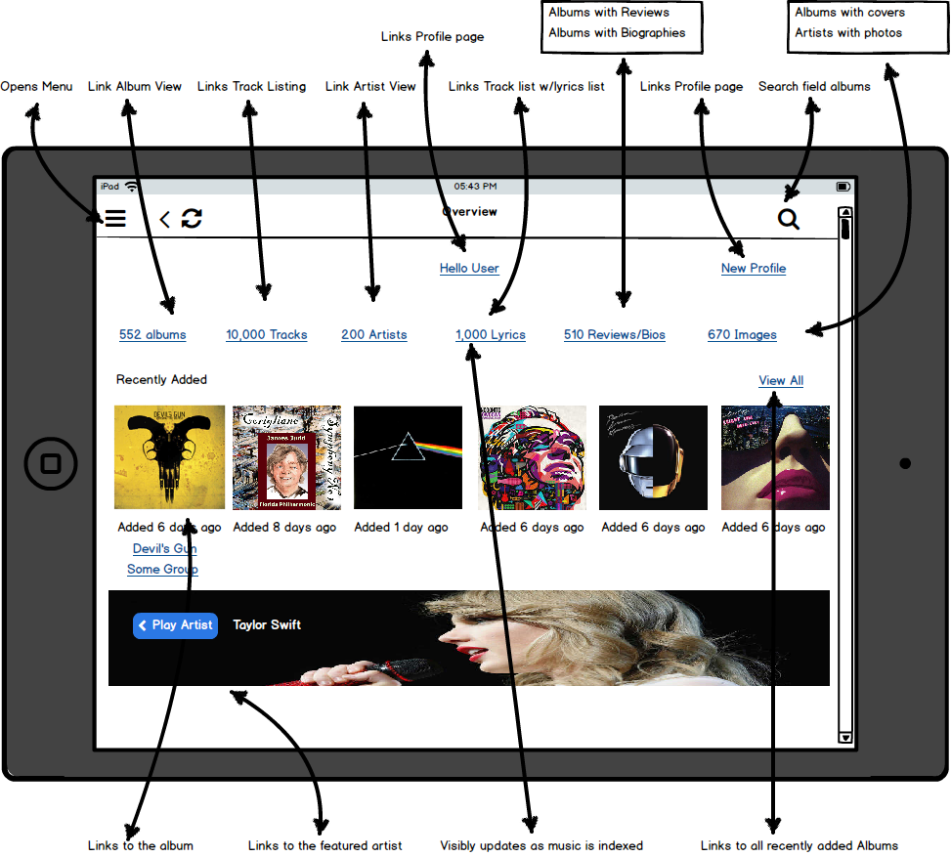
Icon | Action | Destination | Sub action | Comments
Menu | Opens new window | Menu Window
Back button | Opens new window | The previously displayed window |  | The last 10 pages should be reachable from this icon
Refresh | Reload this window
Search | Loads pop up and keyboard | Search window | See Search window function section
Hello User | Opens new window | Profile window |  | User is the last username used
New Profile | Opens new window | Profile window
XXX Albums | Opens new window | Album window |  | XXX is the number of albums in the database that are currently able to be played
XXX Tracks | Opens new window | Tracks window |  | XXX is the number of tracks in the database that are currently able to be played
XXX Artists | Opens new window | Artist window |  | XXX is the number of unique artist names in the database that are currently able to be played
XXX Lyrics | Opens new window | Tracks window | Loads only tracks that have associated Lyrics | XXX is the number of tracks in the database that have associated lyrics that are currently able to be played
XXX Reviews | Opens new window | Album window | Loads only albums that have associated reviews/bios | XXX is the number of albums in the database that have associated reviews/bios that are currently able to be played
XXX Images | No Action??? |  |  | XXX is the number of images in the database
Recently added | No Action |  | Below this text are cover art pictures showing the past 6 albums that have been added to the library | This is just text intended to visually separate the upper selections from the album art shown below
View All | Opens new window | Album window
Album art of recently added albums | Opens new window | Single Album window |  | Same action for any of the albums selected
Album artist name of recently added album | Opens new window | Album window | Loads only albums by this artist
Group name of recently added album | Opens new window | Album window | Loads only albums associated with this group
Play artist | ???
Featured artist pic | Opens new window | Single artist window |  | Default artist pic should be the last one shown, or if none available, the last one added

Overview page continued
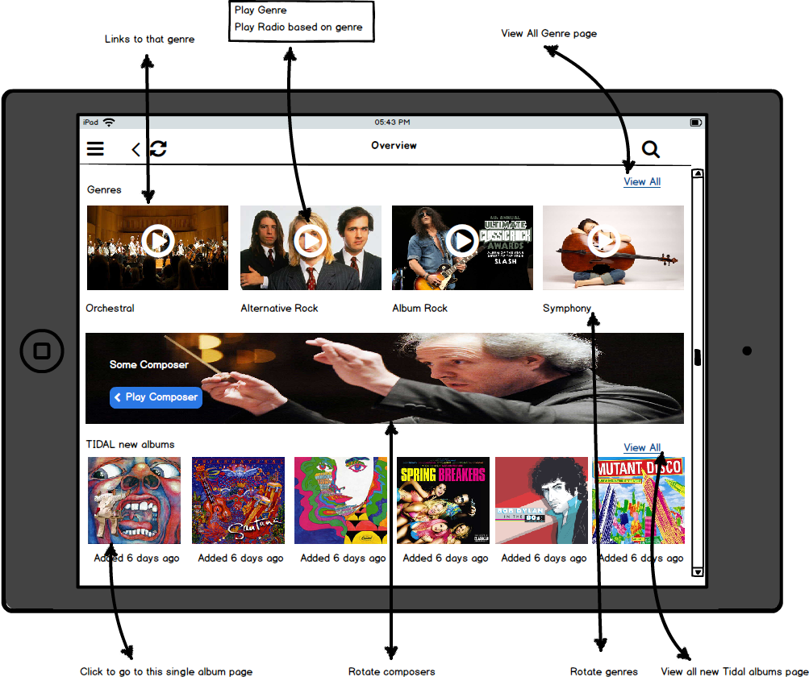

Icon | Action | Destination | Sub action | Comments
Genres | No Action |  |  | This is just text
View All | Open new window | Genre select Window
Genre list with associated photo | Opens new window | Window for selected Genre |  | Photos are of the 4 most played Genres. If none have been played then any 4
Play icon within Genre photo | Plays random track selection from this Genre, and opens new window | Single album window |  | Selection from library chosen first. If none then stream radio station
Picture of Composer | Opens new window | Composer window
Play Composer icon | Plays random track from this composer, and opens new window | Single album window
Tidal new albums | No Action |  |  | This is just text
Tidal new album art | Opens new window | Single album window

Overview window continued
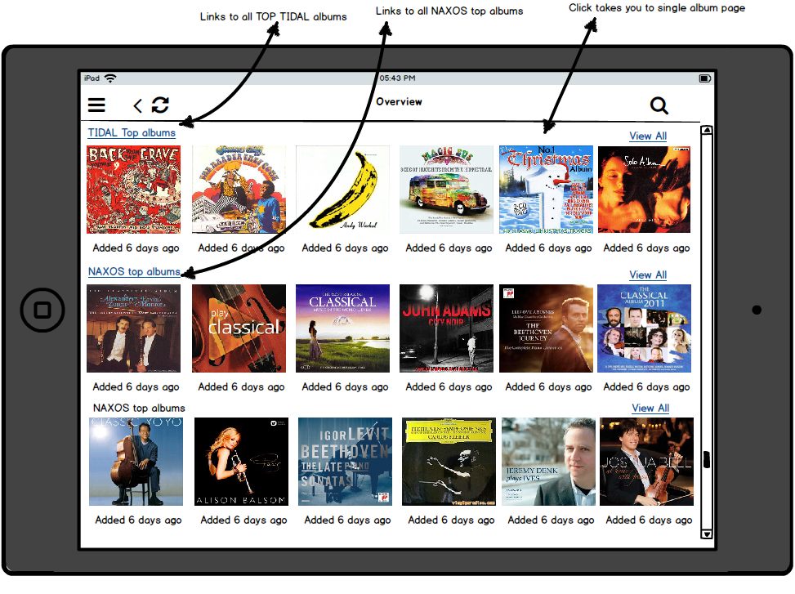
Icon | Action | Destination | Sub action | Comments
Tidal top Albums | Opens new window | Tidal top albums window |  | Shows top 6 albums
View All | Opens new window | Tidal album window
Album art photo of Tidal top albums | Opens new window | Single Album window
Naxos top albums | Opens new window | Naxos top albums window |  | Shows top 6 albums
View all | Opens new window | All Naxos albums
Album art photo of Naxos top albums | Opens new window | Single album window

Menu Window
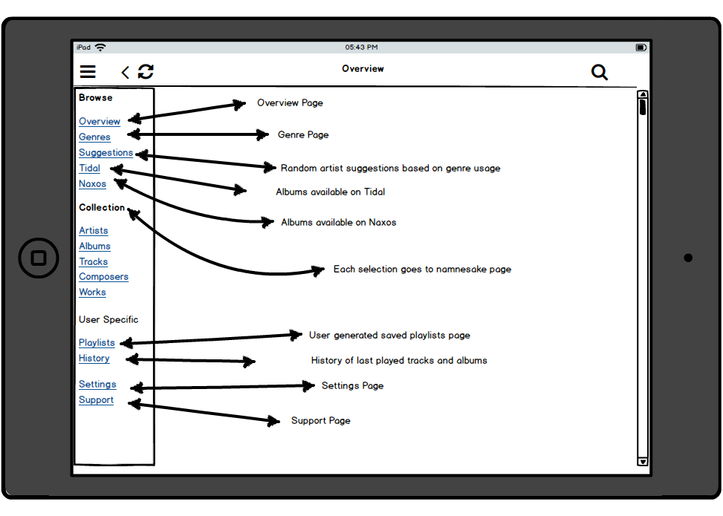

Icon | Action | Destination | Sub action | Comments
Browse |  |  |  | Text only
Overview | Open new window | Overview window
Genres | Open new window | Genre select window
Suggestions | Open new window | Suggestions window
Tidal | Open new window | Tidal album window
Naxos | Open new window | Naxos album window
Collection |  |  |  | Text only
Artists | Open new window | Artist window
Albums | Open new window | Album window
Tracks | Open new window | Tracks window
Composers | Open new window | Composers window
Works | Open new window | Works window
User Specific |  |  |  | Text only
Playlists | Open new window | Playlist window
History | Open new window | History window
Settings | Open new window | Settings window
Support | Open new window | Support window

Album Window
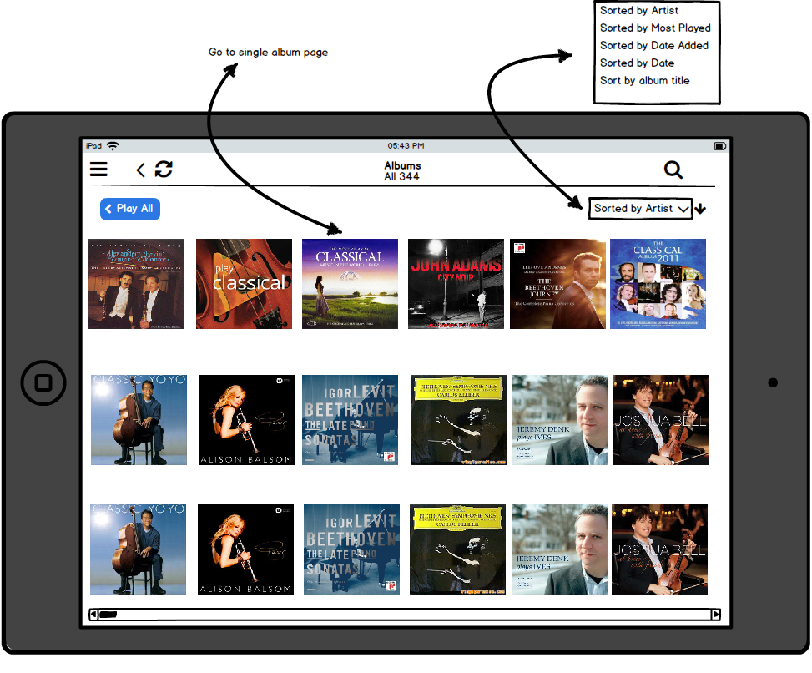

Icon | Action | Destination | Sub action | Comments
Play all | TBD
Sort pull down | Show pull down
 |  | Sort by Artist | Redistribute album art alphabetically by artist
 |  | Sort by most played | Redistribute album art by amount each album has been played
 |  | Sort by Date added | Redistribute album art from the newest album added to the oldest
 |  | Sort by Date | Redistribute album art from the newest release date to the oldest
 |  | Sort by Album title | Redistribute album art alphabetically by album title
Any of the album art pics | Open new window | Single album window

Tracks window
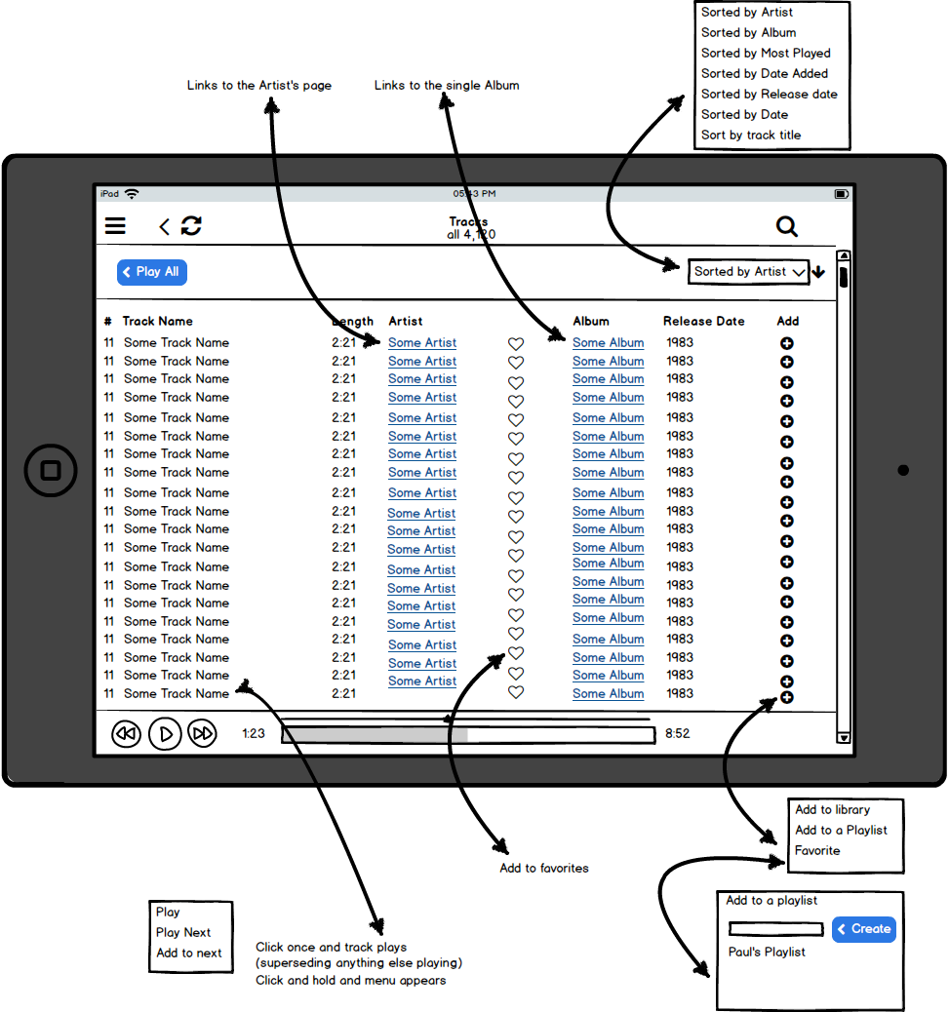

Icon | Action | Destination | Sub action | Comments
Play all | TBD
Sort pull down | Show pull down
 |  | Sort by Artist | Redistribute track list alphabetically by artist
 |  | Sort by album | Redistribute track list alphabetically by album name
 |  | Sort by most played | Redistribute track llist by amount each track has been played
 |  | Sort by Date added | Redistribute track list from the newest track added to the oldest
 |  | Sort by Date | Redistribute track list from the newest release date to the oldest
 |  | Sort by Track title | Redistribute album art alphabetically by track title | This view is the default when entering this window
Any individual track name | Click only immediately play this track and keep this window view
 | Click and hold opens a pull down menu | Play | Play immediately
 |  | Play Next | Place track as next in queue
 |  | Add to next | Place track at the end of the current queue
Any individual Artist name | Opens new window | Single Artist Window for this artist
Heart symbol | Add this track to favorites playlist
Any individual album name | Opens new window | Single album window
Add | Opens popup window | Add to library | TBD
 |  | Add to a playlist | Opens additional popup window listing all of the available playlists with an additional button option to create a new playlist. Selecting from this list adds this track to the selected playlist
 |  | Add to favorites | Adds this track to favorites playlist

Artist Window
Icon | Action | Destination | Sub action | Comments
Play all | TBD
Sort pull down | Show pull down
 |  | Sort by name | Redistribute artist pics alphabetically
 |  | Sort by most played | Redistribute artist pics by the number of times the artist has been played from most to least
 |  | Sort by Date added | Redistribute artist pics by the most recent date the artist was added to the library
 |  | Sort by Album count | Redistribute the artist pics by the number of albums the artist is on, from most to least
Any individual artist | Open new window | Single artist window
Single Album Window
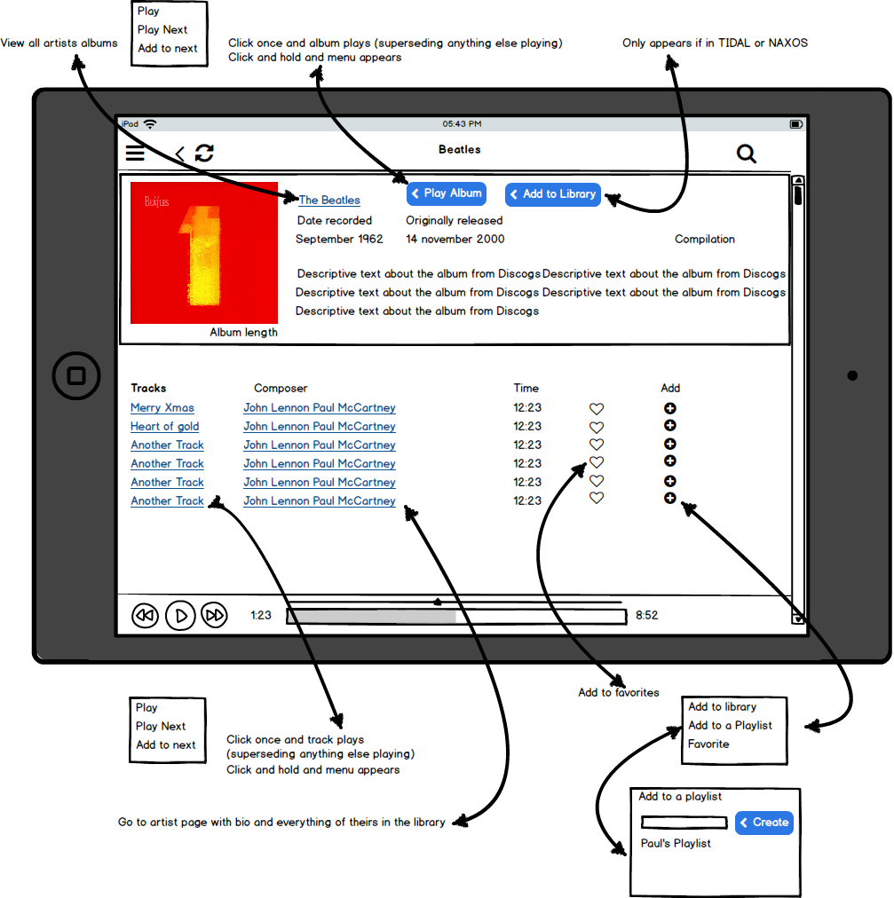

Icon | Action | Destination | Sub action | Comments
Artist name | Open new window | Single artist window
Play Album | Click only - first track in album plays immediately with remaining tracks put in queue
 | Click and hold - opens pop up window | Play | first track in album plays immediately with remaining tracks put in queue
 |  | Play next | Place all album tracks in queue to be played at the completion of the current track
 |  | Add to next | Place all album tracks at the end of the current queue
Add to library | TBD
Any of the individual track names | Click only - track plays immediately
 | Click and hold - opens pop up window | Play | track plays immediately
 |  | Play next | Place track as next in queue
 |  | Add to next | Place track at the end of the current queue
Any of the names in the composer list | Open new window | Single artist window
Heart | Adds the particular track associated with the row that this heart icon was clicked to the favorites playlist
Add | Opens popup window | Add to library | TBD
 |  | Add to a playlist | Opens additional popup window listing all of the available playlists with an additional button option to create a new playlist. Selecting from this list adds this track to the selected playlist
 |  | Add to favorites | Adds this track to favorites playlist

Single Artist Window

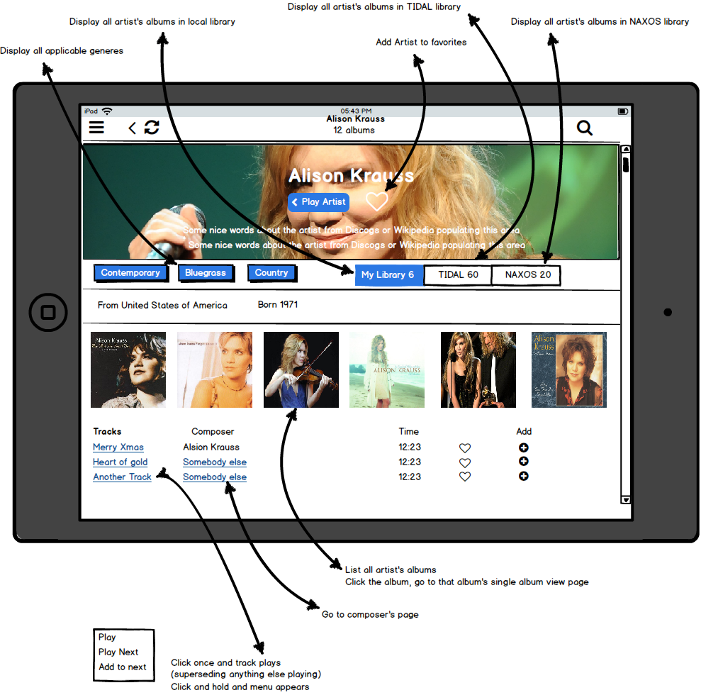

Icon | Action | Destination | Sub action | Comments
Play artist | TBD
Heart icon in bio area | Add artist to favorites table
Genre button | Display only albums and tracks from this artist that have this genre
MyLibrary | Display only albums and tracks within the chosen library
Tidal | Display only albums and tracks for this artist that are in the Tidal library
Naxos | Display only albums and tracks for this artist that are in the Naxos library
Individual track name | Click only - track plays immediately
 | Click and hold - opens pop up window | Play | track plays immediately
 |  | Play next | Place track as next in queue
 |  | Add to next | Place track at the end of the current queue
Composer name other than the current artist | Open new window | Single composer window
Any individual album art icon | Open new window | Single Album window
Heart icon | Add the track associated with this row to the favorites playlist
Add Icon | Open pop up window | Add to library | TBD
 |  | Add to a playlist | Opens additional popup window listing all of the available playlists with an additional button option to create a new playlist. Selecting from this list adds this track to the selected playlist
 |  | Add to favorites | Adds this track to favorites playlist

Genre Window

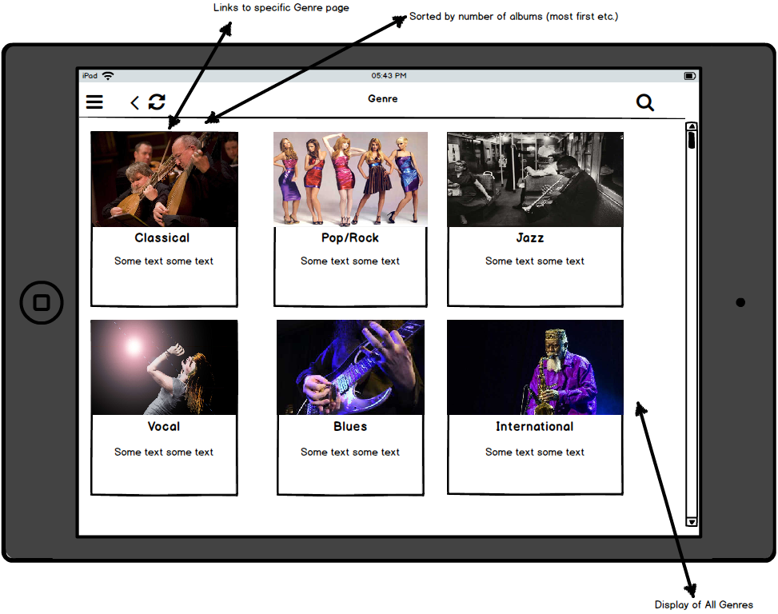

Icon | Action | Destination | Sub action | Comments
Individual Genre icon | Open new window | Selected Genre window

Selected Genre Window

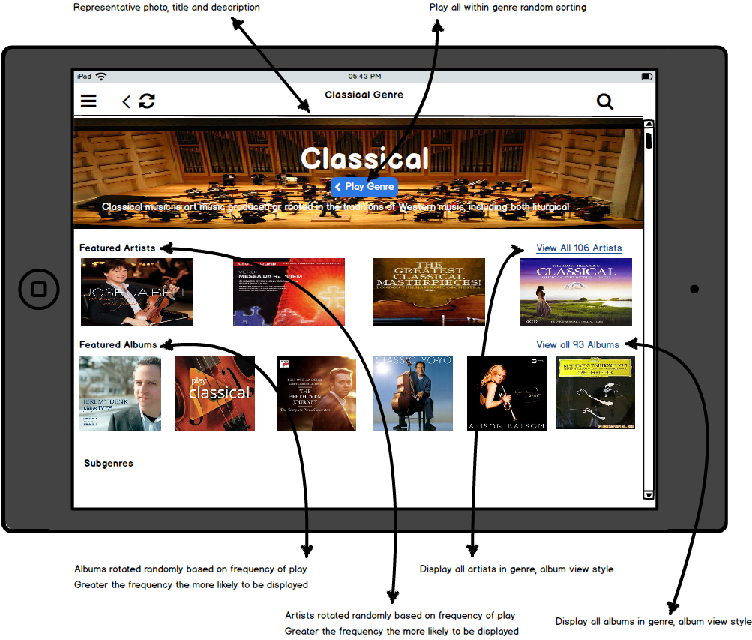

Icon | Action | Destination | Sub action | Comments
Play Genre | Immediately start playing random selections from this genre |  |  | Queue is all of the tracks of this genre
Individual Artist icon | Open new window | Single artist window
Individual Album icon | Open new window | Single Album window
View all artists | Show all artists within this genre on screen
View all albums | Show all albums within this genre on screen

Selected Genre Window continued

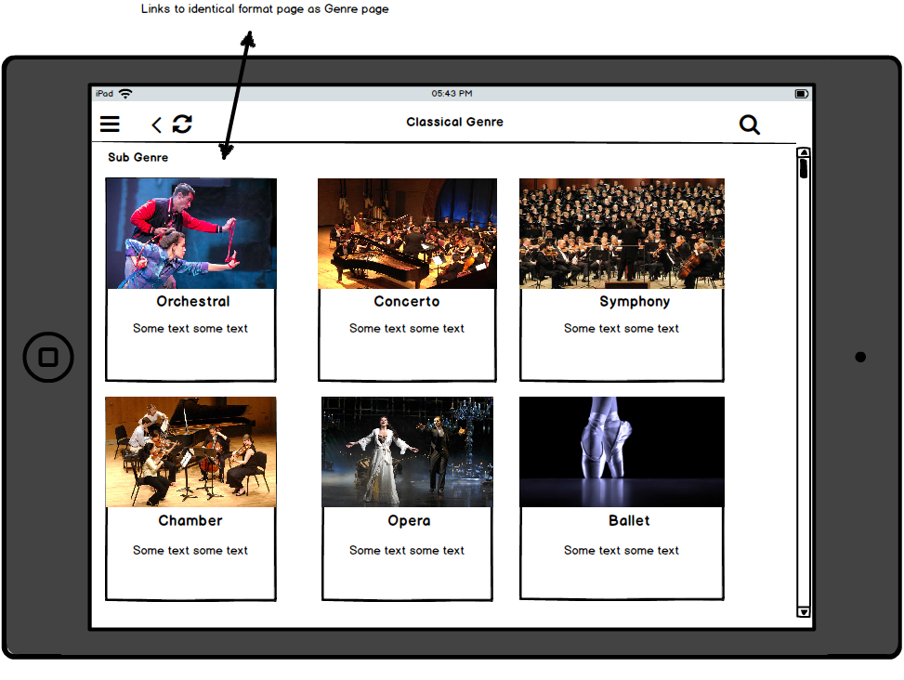
Icon | Action | Destination | Sub action | Comments
Individual subgenre icon | Open new window | Reopen selected genre window with this subgenre as the genre

Composer Window
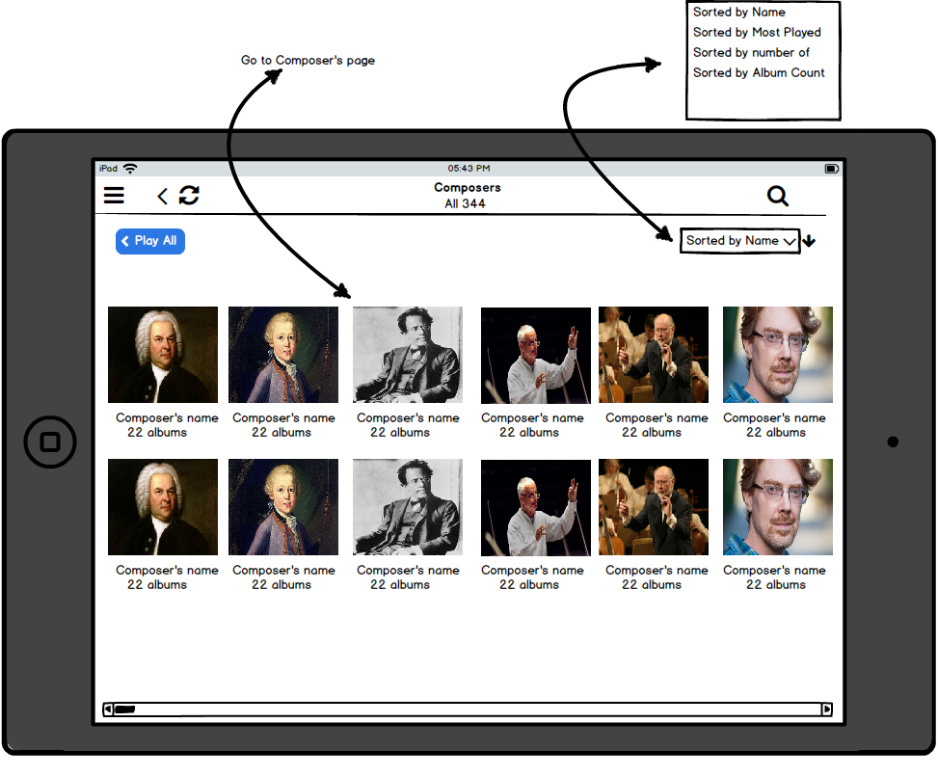

Icon | Action | Destination | Sub action | Comments
Play all | Immediately start playing random selections from this list of composers |  |  | Queue is all of the tracks of this list of composers
Individual composer icon | Open new window | Single composer window
Sort pull down | Open popup window
 |  | Sort by name | Redistribute composer pics alphabetically
 |  | Sort by most played | Redistribute composer pics by the number of times the composer has been played from most to least
 |  | Sort by number of albums | Redistribute composer pics by the most number of albums attributed to this composer | Does this include Tidal and/or Naxos?

Selected Composer Window

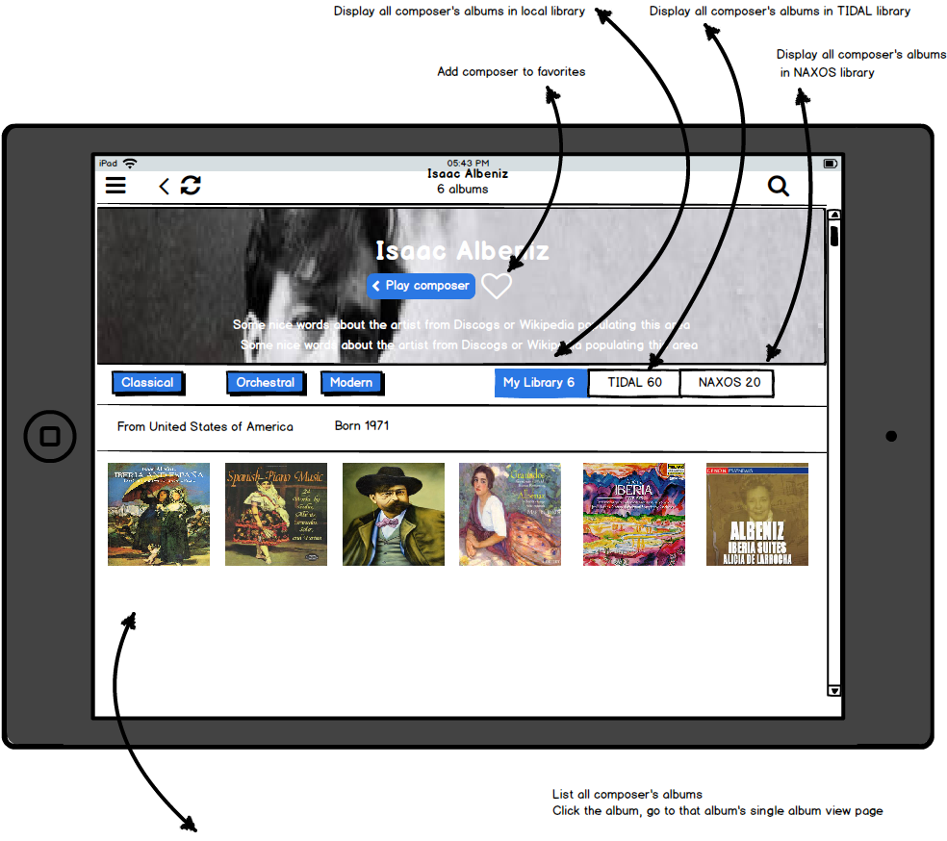

Icon | Action | Destination | Sub action | Comments
Play composer | Immediately start playing random selections from this composer |  |  | Queue is all of the tracks of this composer
Individual subgenre icon | Show albums only within this subgenre
Heart icon in composer bio section | Add this composer to favorites list
My Library icon | Display only albums from this composer that are in the local library
Tidal | Display only albums from this composer that are in the Tidal library
Naxos | Display only albums from this composer that are in the Naxos library
Tracks????

Tidal Window
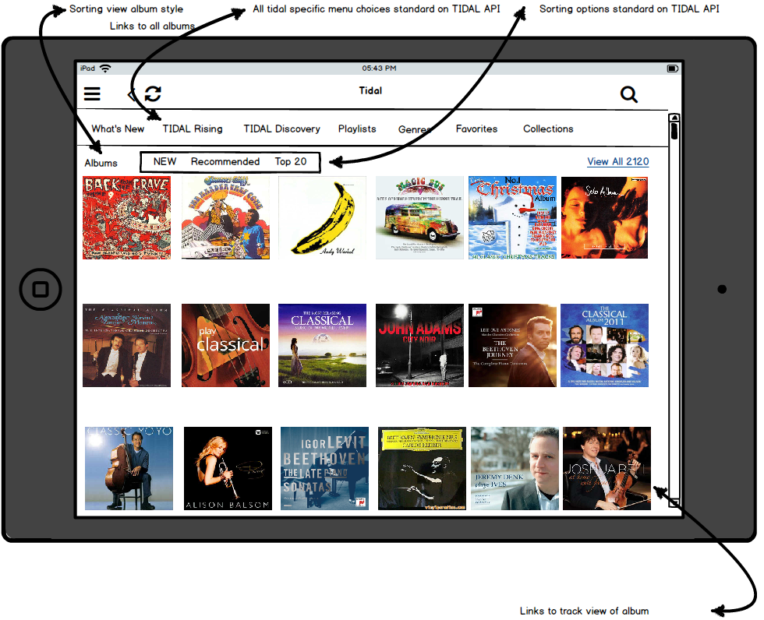

Icon | Action | Destination | Sub action | Comments
What’s new | TBD
Tidal Rising | TBD
Tidal Discovery | TBD
Playlists | TBD
Genres | TBD
Favorites | TBD
Collections | TBD
Albums New | TBD
Albums Recommended | TBD
Albums Top 20 | TBD
Individual Album icon | TBD
Tidal Window continued
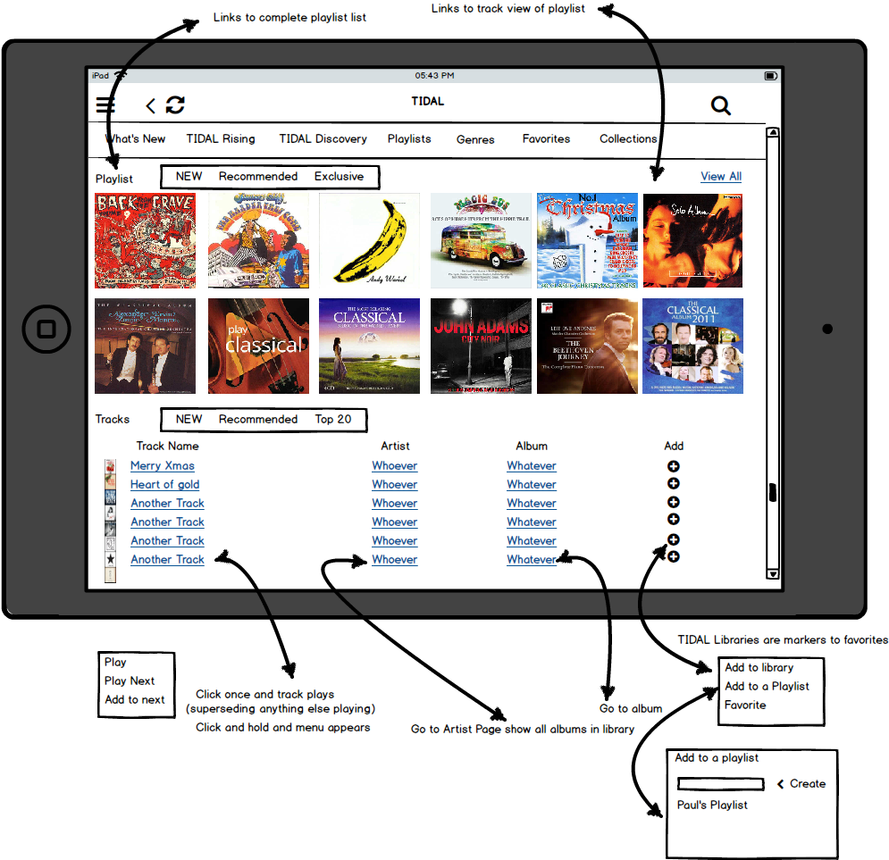

Icon | Action | Destination | Sub action | Comments
Playlist New | TBD
Playlist recommended | TBD
Playlist exclusive | TBD
View All | TBD
Tracks New | TBD
Tracks Recommended | TBD
Tracks Top 20 | TBD
Individual track name | Click only - track plays immediately
 | Click and hold - opens pop up window | Play | track plays immediately
 |  | Play next | Place track as next in queue
 |  | Add to next | Place track at the end of the current queue
Individual Artist | Opens new window | Selected Artist window
Individual Album | Opens new window | Selected Album window
Add Icon | Open pop up window | Add to library | TBD
 |  | Add to a playlist | Opens additional popup window listing all of the available playlists with an additional button option to create a new playlist. Selecting from this list adds this track to the selected playlist
 |  | Add to favorites | Adds this track to favorites playlist
Add

Naxos Window
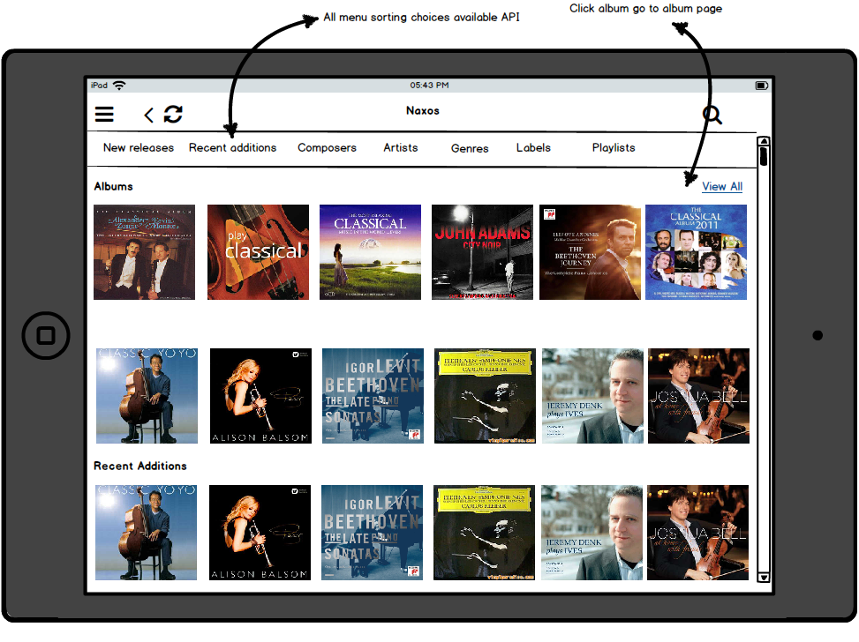

Icon | Action | Destination | Sub action | Comments
New releases | TBD
Recent additions | TBD
Composers | TBD
Artists | TBD
Genres | TBD
Labels | TBD
Playlists | TBD
View All | TBD
Individual Album art icon | Open new window | Selected Album window

Naxos Window continued
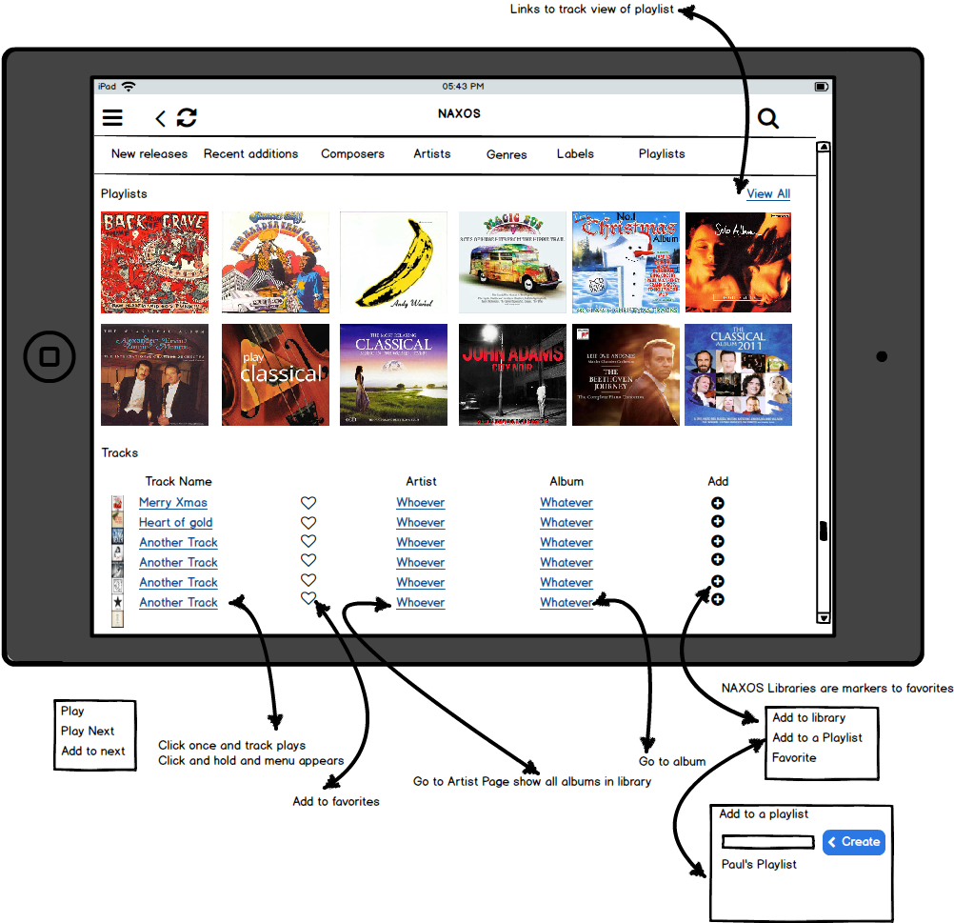

Icon | Action | Destination | Sub action | Comments
Individual track name | Click only - track plays immediately
 | Click and hold - opens pop up window | Play | track plays immediately
 |  | Play next | Place track as next in queue
 |  | Add to next | Place track at the end of the current queue
Individual Artist | Opens new window | Selected Artist window
Individual Album | Opens new window | Selected Album window
Add Icon | Open pop up window | Add to library | TBD
 |  | Add to a playlist | Opens additional popup window listing all of the available playlists with an additional button option to create a new playlist. Selecting from this list adds this track to the selected playlist
 |  | Add to favorites | Adds this track to favorites playlist

Suggestions Window
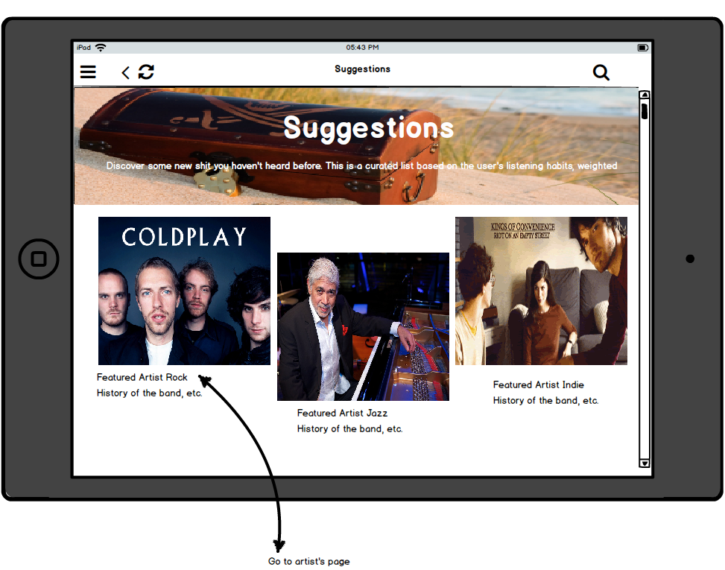

Icon | Action | Destination | Sub action | Comments
Individual artist | Open new window | Selected artist window |  | How is this screen populated?

Works Window
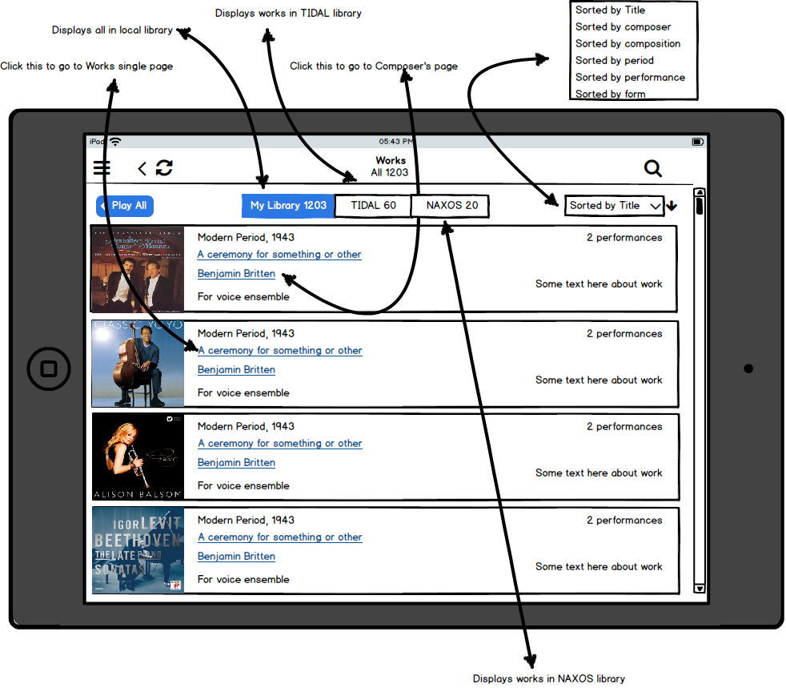

Icon | Action | Destination | Sub action | Comments
Play all | TBD
MyLibrary | Display only works within the chosen library
Tidal | Display only works that are in the Tidal library
Naxos | Display only worksthat are in the Naxos library
My Library
Sort by pull down | Open pop up window | Sort by title | Arrange display alphabetically by Works title
 |  | Sort by composer | Arrange display alphabetically by composer name
 |  | Sort by composition | Arrange display alphabetically by composition name
 |  | Sort by period | Arrange display chronologically from newest period to oldest
 |  | Sort by performance | Arrange display alphabetically by performance
 |  | Sort by form | TBD
Individual composer | Open new window | Selected composer window
Individual works selection | Open new window | Selected works window

Selected Works Window
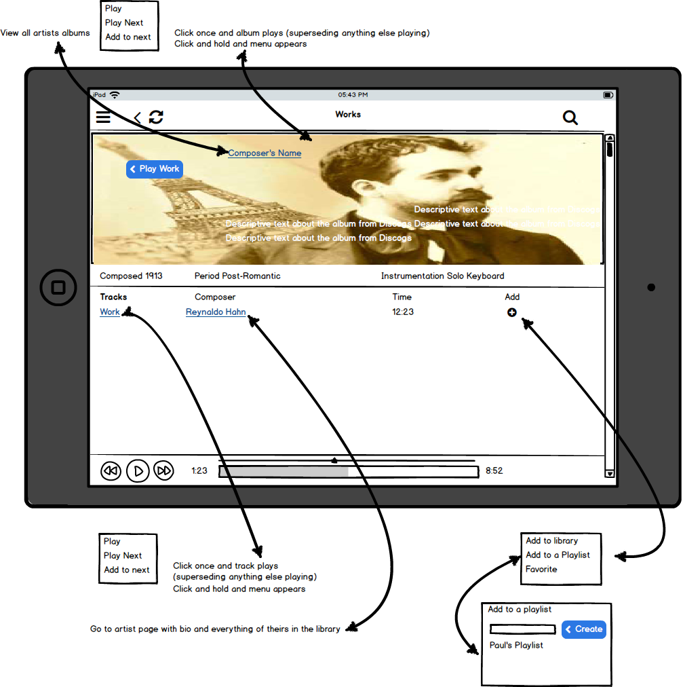

Icon | Action | Destination | Sub action | Comments
Play work | Click only - Album plays immediately beginning with track 1
 | Click and hold - opens pop up window | Play | Album plays immediately
 |  | Play next | Place all album tracks as next in queue
 |  | Add to next | Place album at the end of the current queue
Composers name | Open new window | Selected Composer window
Individual track icon | Click only - Track plays immediately
 | Click and hold - opens pop up window | Play | track plays immediately
 |  | Play next | Place track as next in queue
 |  | Add to next | Place track at the end of the queue
Individual composer name | Open new window | Selected Composer window
Add Icon | Open pop up window | Add to library | TBD
 |  | Add to a playlist | Opens additional popup window listing all of the available playlists with an additional button option to create a new playlist. Selecting from this list adds this track to the selected playlist
 |  | Add to favorites | Adds this track to favorites playlist

History Window
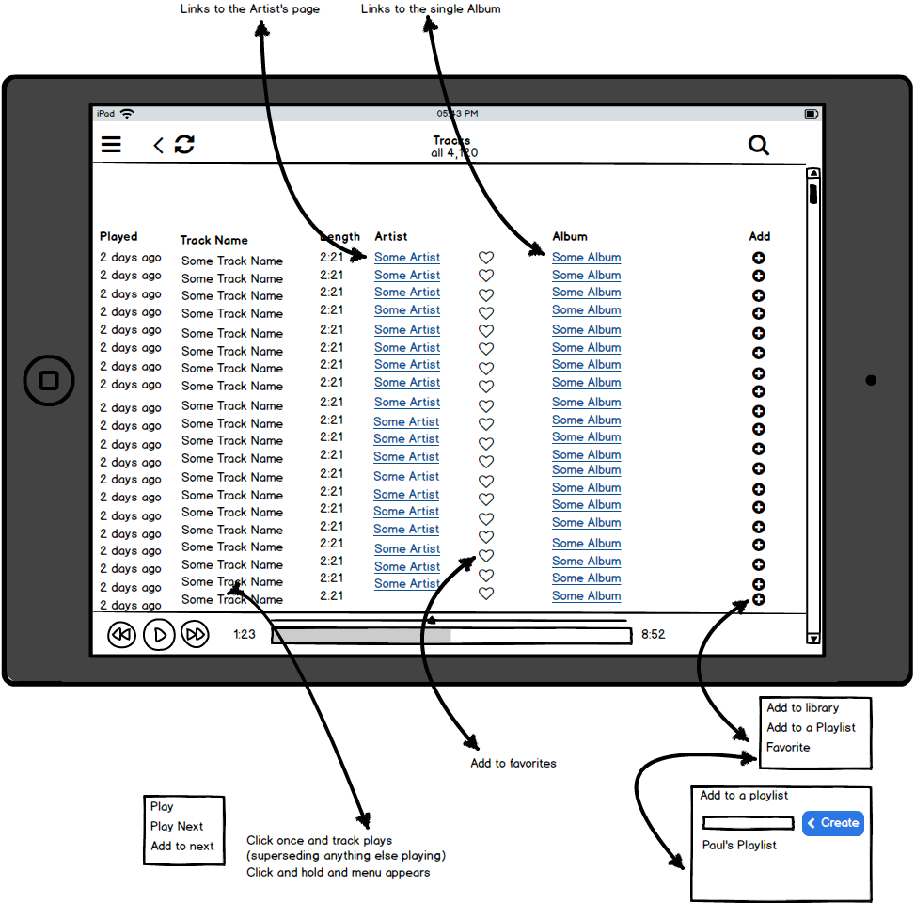

Icon | Action | Destination | Sub action | Comments
Individual track name | Click only - track plays immediately
 | Click and hold - opens pop up window | Play | track plays immediately
 |  | Play next | Place track as next in queue
 |  | Add to next | Place track at the end of the current queue
Individual Artist name | Opens New Window | Selected artist window
Heart icon | Add track to favorites playlist |  |  | How to indicate it was done?
Individual album icon | Open new window | Selected album window
Add Icon | Open pop up window | Add to library | TBD
 |  | Add to a playlist | Opens additional popup window listing all of the available playlists with an additional button option to create a new playlist. Selecting from this list adds this track to the selected playlist
 |  | Add to favorites | Adds this track to favorites playlist

Profile Window

TBD

Settings Window

TBD

Support Window

TBD

- Interfacing Software (Web Page)

Similar to #4, but limited to a web UI. This should specify browsers to support (ex: Firefox 41+), operating systems they run on (ex: Windows 7). Similar to #4, this should include a set of features, wireframes and eventually full designs.
    - 7 Questions to be Resolved

  - Reference hardware for development. What’s the timeline?
  - How does the hardware vary across implementations of the product?
  - Updates. What should the update system be capable of doing? How frequency should updates be?
  - How to handle users with their own metadata, especially if it is high-quality metadata?
  - Will the DB capabilities be constrained by hardware or software or both? Likely need more data on the schema before this can be answered.
  - Do we need the web interface in version 1?
  - Mobile application delivery via app store?
  - Do we need to support Android in version 1?
  - What percent of the target audience uses Android?
  - How to select representative Android hardware should we support the platform?

