Remove front panel:
Turn unit on its side. Carefully remove rubber feet pads then remove 4 screws on the front feet.

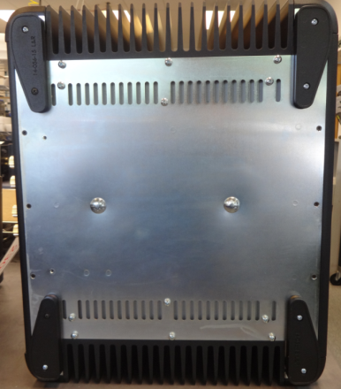
Remove 5 screws holding the front panel.
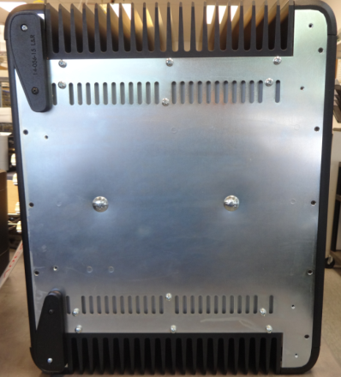
Remove 3 screws holding the Heat sink assembly.

Remove top cover:
Remove qty 4, 8-32 x ¾ inch socket head cap screws in locations shown (4 on each side).
Note: The two top screws allow removal of the top. The two lower screws allow removal of the front panel.

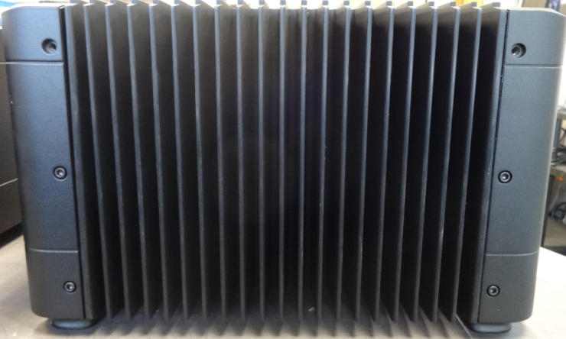
F
R
O
N
T
Lift top off by pulling up on the backside of the lid assembly.
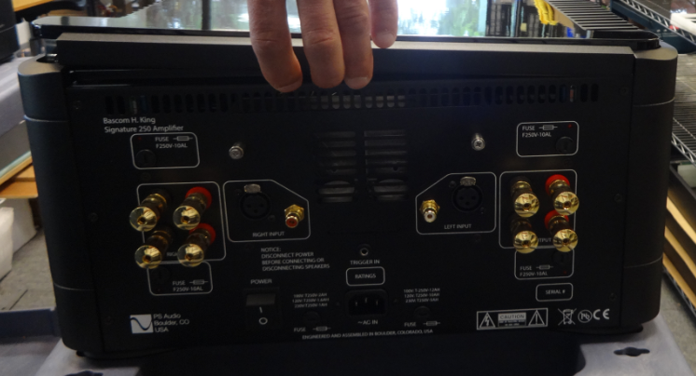

Remove Input board:
Remove tube cover, loosen screws on cover.

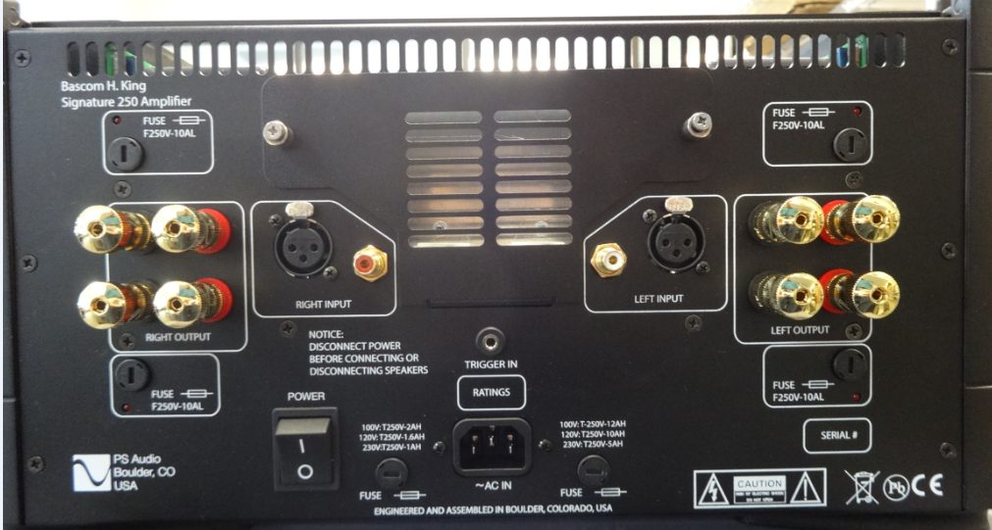
Remove 4 screws holding the Input board bracket.
Remove nuts and washers on RCA jacks. (2 for Stereo, 1 for Mono units)
Remove screws on XLR connectors. (4 for Stereo, 2 for Mono units)

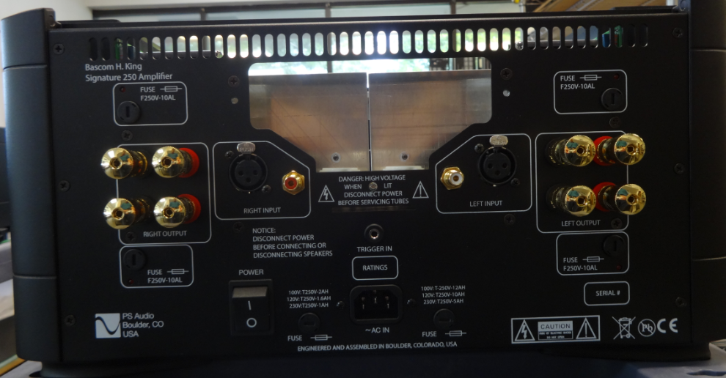

Remove 8 connectors to the Input board.
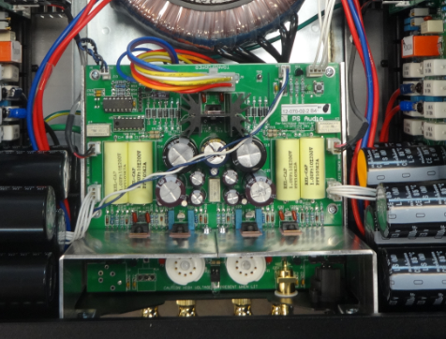

Press the Input board down, to allow the XLR clips to pass thru the rear panel holes. Carefully pull the input board back and disconnect the ground wire (Mono) from ground distribution lug.

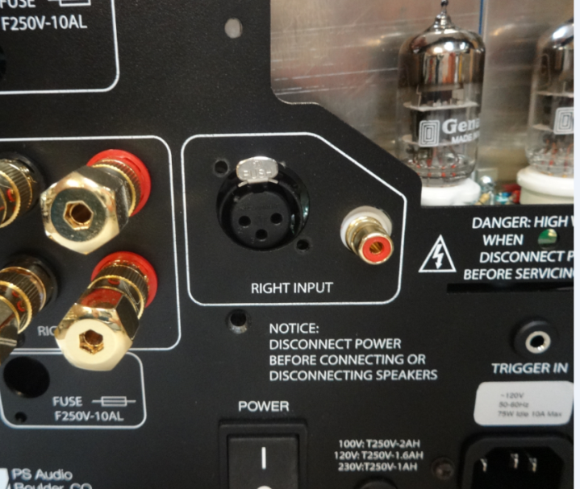

Cut tie wrap on ground wires to allow the heatsink assembly to be removed. Disconnect the Output board ground wire from ground distribution lug.

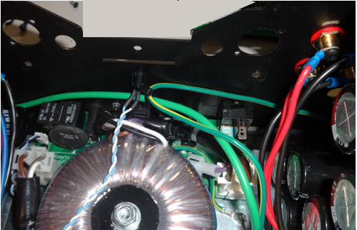

Remove 2 screws holding the heat sink assembly on the back of the unit.

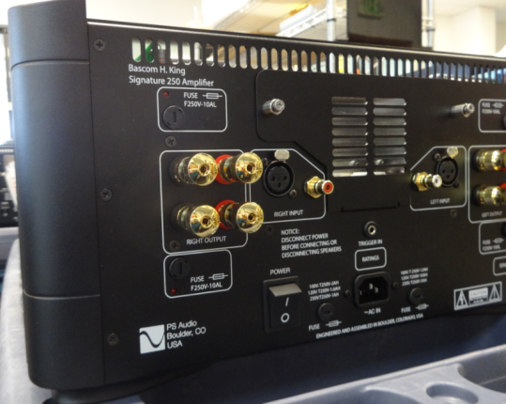
Slide heat sink back from unit (use caution not to scratch the bottom of the heat sink)
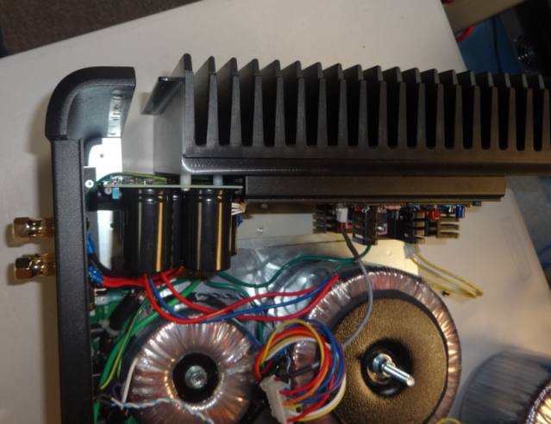

Remove Transformer connector from board (squeeze side connector tabs.) Unscrew binding post wires from output board. Remove output board from the unit.
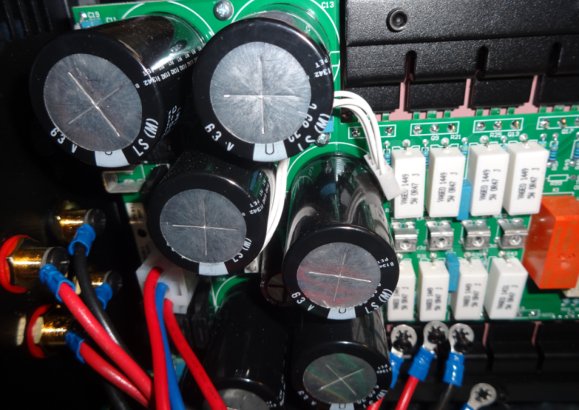

Heatsink Disassembly/Assembly
Note: Handle PCB assemblies at an ESD protected work station using a wrist strap.
Remove 8 screws on heat sink brackets.
Remove 3 screws that attach the daughter card.
Remove 4 screws that attach the Output board to the heatsink.
Remove the Output board from the heatsink.
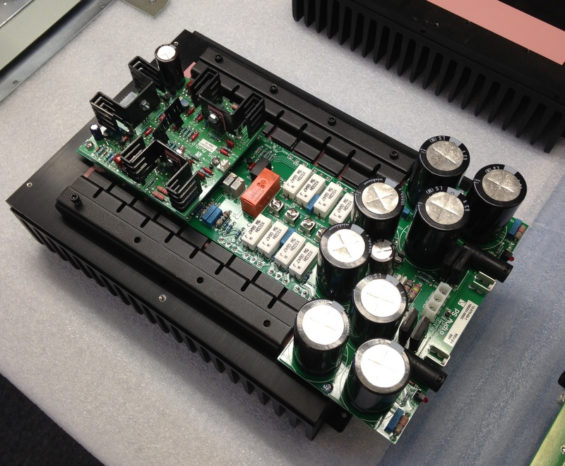
Remove silpad and replace with new silpad strips.
Center left to right and align with edge of bracket mounting holes as shown.

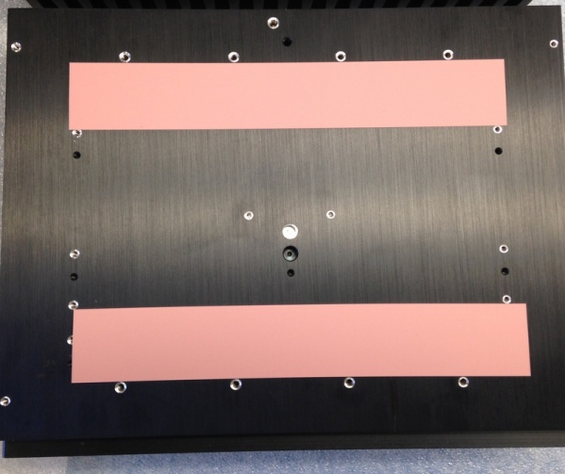

Locate PCB over heat sink mounting holes and install 4 qty 4-40 X ½ inch PH screws at capacitor end of PCB.

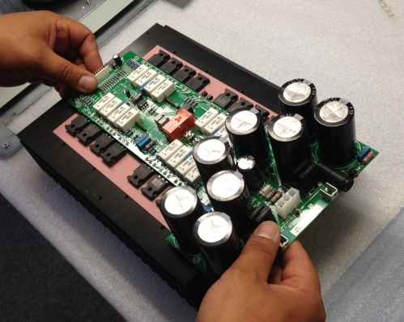

Mount PABA assembly to heat sink. Secure with 3 qty 4 X 1-1.8 inch PPH screws around daughter board. And install 4 qty 4 X ¾ inch screws at capacitor end of PCB. Torque to 10 in/lb.

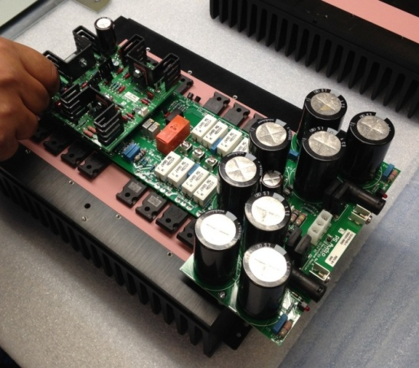
Install transistor hold-down brackets
Put brackets in place making sure bracket with pad is centered over TO-92 transistors. Secure both brackets with 8 qty 6-32 X 1 inch socket head cap screws. Tighten to 20 inch lbs.

Re-check the torque on each screw after all screws have been tightened- tightening screws will affect the torque of the other screws.

